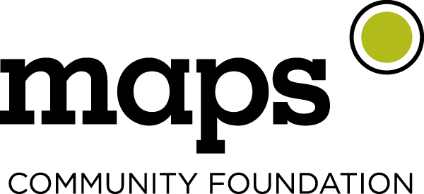
NEWS RELEASE
Kim Hanson, Executive Director
Email: khanson@mapscu.com
Office: 971-382-0177
Mobile: 503-881-4388

Teacher Grant Program Awards 41 Mid-Willamette Valley Teachers
Maps Community Foundation gives $35,000 to local schools

SALEM, Ore. Dec. 5, 2023—Maps Community Foundation announces 41 grant awards to local K-12 teachers—the most ever in the history of the program. In total, the Foundation awarded $35,000 in teacher grants this year. Winners were selected by Maps branch employees based on geographic area. Grant awards are for innovative classroom and schoolwide projects benefiting students in the Marion-Polk region.
Teachers across the region will be using the grants to fund a wide-range of projects including purchasing books and hosting family literacy events to encourage reading, adding flexible seating and sensory tools in classrooms and calming spaces, creating school gardens, field trips, music programs, after-school clubs, and more. Maps Community Foundation’s Teacher Grant Program is part of the Education impact area, which is the largest area of giving because of Maps’ dedication to its roots as a teacher’s credit union.
Kim Hanson, Maps Community Foundation’s Executive Director says, "We received a record number of applications this year and are honored to be supporting this group of exceptional teachers and their impactful projects. We are so inspired by the dedication of all of our local educators and the difference they make in the lives of their students.”

A sampling of the 21 Awardees from Salem include:

- Phillip Warner of McKay High School will take his AP Environmental Science class on a field trip to the Hatfield Marine Science Center
- Jasmine Filley of the Career Technical Education Center (CTEC) will purchase tower garden vertical aeroponic systems for two nearby elementary schools so that CTEC students can share their knowledge with younger students.
- Kezra Presleigh of Stephens Middle School will develop a new Ethnic Studies elective course with grant funds supporting training, student materials, and field trips.
- Shelly Barr of Crossler Middle School will purchase items for the school clothing closet so that students who are experiencing financial hardship can receive the support they need to be successful learners.
- Liza Rodriguez McNicholas of South Salem High School will use the funds to support her work with the after-school Latino Club, including club t-shirts and multicultural week activities.
- Brenda Varty Bly of McKinley Elementary School will purchase a sensory swing, a smart recording bird feeder and other bird-related items to enhance the calm, sensory den.
- Kassandra Paige of Auburn Elementary School will bring the twelve-week Biz Town financial education program to her 4th and 5th grade students.
- Kim Beranek of Mary Eyre Elementary School will purchase a new mobile digital piano that can be used in the music room, library, and gym to accompany music classes and concerts.
- Dan Murray of West Salem High School will utilize funds for a 10-week real-world budgeting simulation to teach financial literacy to his financial algebra students.
- Kevin Loss of Parrish Middle School will use funds to support the creation of a Sensory Solarium in the greenhouse to provide a safe and nurturing space for students with developmental disabilities to regulate their bodies and minds.
- Kristine Herring of Eagle Charter School will purchase practical items to be given to students as part of their new monthly Character Trait Awards, recognizing kindness, empathy, respect, responsibility, honesty, and cooperation.
- Melissa Garmon of St. Vincent de Paul Dual Language Immersion Catholic School will purchase bilingual literacy materials to support her English reading intervention groups. Melissa Garmon of St. Vincent de Paul Dual Language Immersion Catholic School will purchase bilingual literacy materials to support her English reading intervention groups.

For a complete list of winners and a description of what each teacher will do with their award, please see winner details at www.mapscu.com/community-involvement/teacher-grants.
# # #

About Maps Community Foundation
Maps Community Foundation is the philanthropic branch of Maps Credit Union, a member-owned financial cooperative with 75,000 members and 10 full-service branches serving the Mid-Willamette Valley region. With a mission of enriching the lives of members and community, the Foundation focuses on improving the quality of life in the communities served by Maps. Community investments are directed in three impact areas: Education, Economic Empowerment, and Vibrant Communities. The Foundation is funded through a penny per swipe program and additional Maps contributions. In 2022, the Foundation distributed more than $400,000 locally. To learn more, visit www.mapscu.com under “Community Foundation.”

